**PREOPERATIVE EVALUATION**

All children must be assessed before anaesthesia and surgery. Establish good rapport with both parent and child to help make the anaesthesia experience a pleasant one.

Pre-operative evaluation of children includes:

a) History

* Perinatal history/ events especially for children less than 6 months of age
* If born premature, the corrected post-menstrual age (PMA) PMA = gestational age + chronological age should be calculated
* Complications related to prematurity if applicable
* Neonatal Intensive Care Unit admission and events if applicable
* History of apnoeic spells
* Current medical problems e.g. congenital heart disease, asthma
* Developmental milestones
* Feeding routines and issues
* Congenital anomalies
* Upper Respiratory Tract Infection (URTI)
* Previous anaesthetic history
* History of motion sickness
* Family history of anaesthesia related problems,
* Drug history including the regular consumption of supplements
* Allergies: drugs, foods, adhesive tapes etc
* Special needs/learning disabilities/behavioural issues

b) Physical Examination

* Any obvious anomalies e.g. dysmorphism, cleft lip/palate
* Airway
* Dentition: presence of loose teeth/ orthodontic devices
* Examination of the cardiovascular and respiratory system
* State of hydration, nutrition
* Developmental/ cognitive/ neurological state
* Vital signs of the child including saturations on room air
* Examination for possible venous access sites
* Height and Weight. (Weight is particularly important as drug dosages are ordered based on it. Height is important for calculating the body mass index (BMI) and body surface area. The latter is applicable in situations such as cardiopulmonary bypass). In obese patients it may be appropriate to use the lean body weight for the dose determination of drugs.

BMI and Obesity in Children

BMI for children and adults are calculated the same way:

BMI = Weight (kg)/ (Height x Height) m2

However, the calculated BMI is *interpreted differently* between children & adults. BMI for children needs to be interpreted in relation to the child’s age & gender by plotting the BMI value on the gender specific BMI-for-age percentile charts provided below.

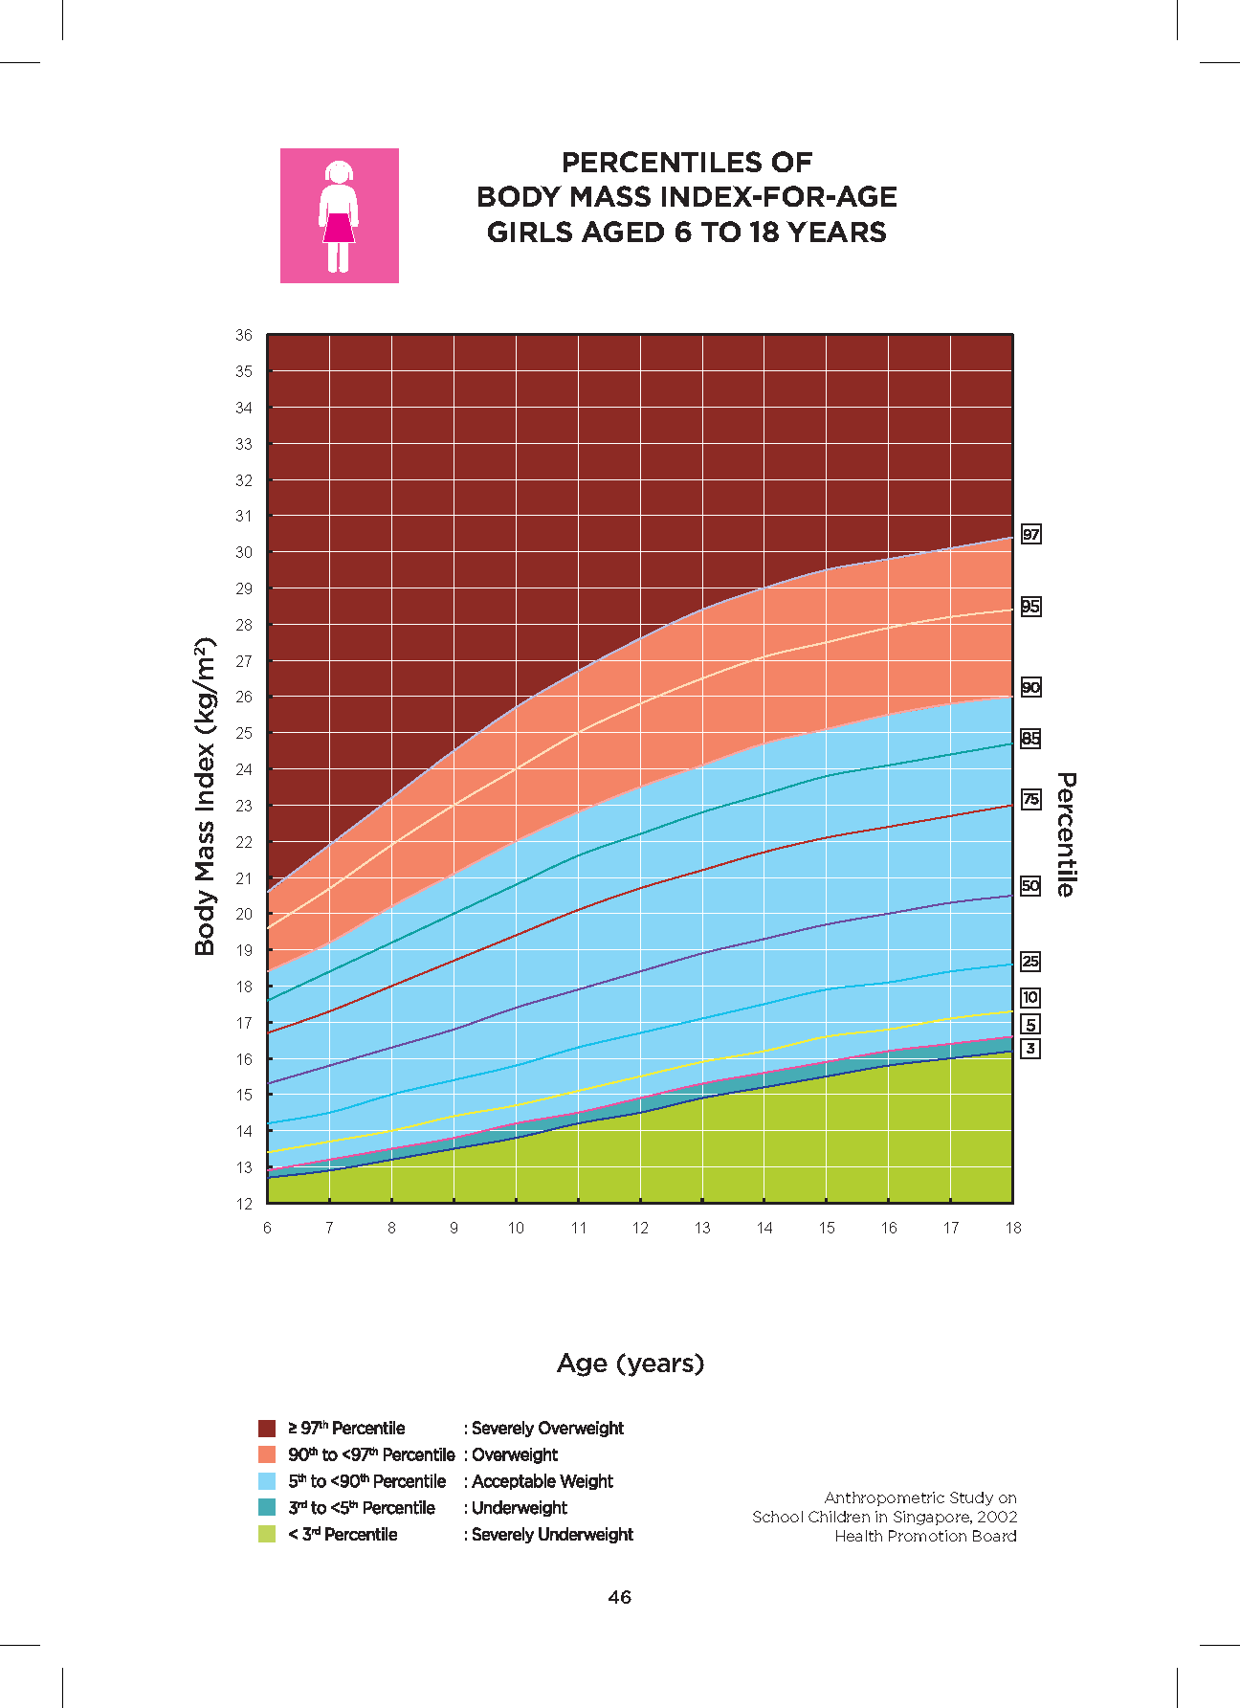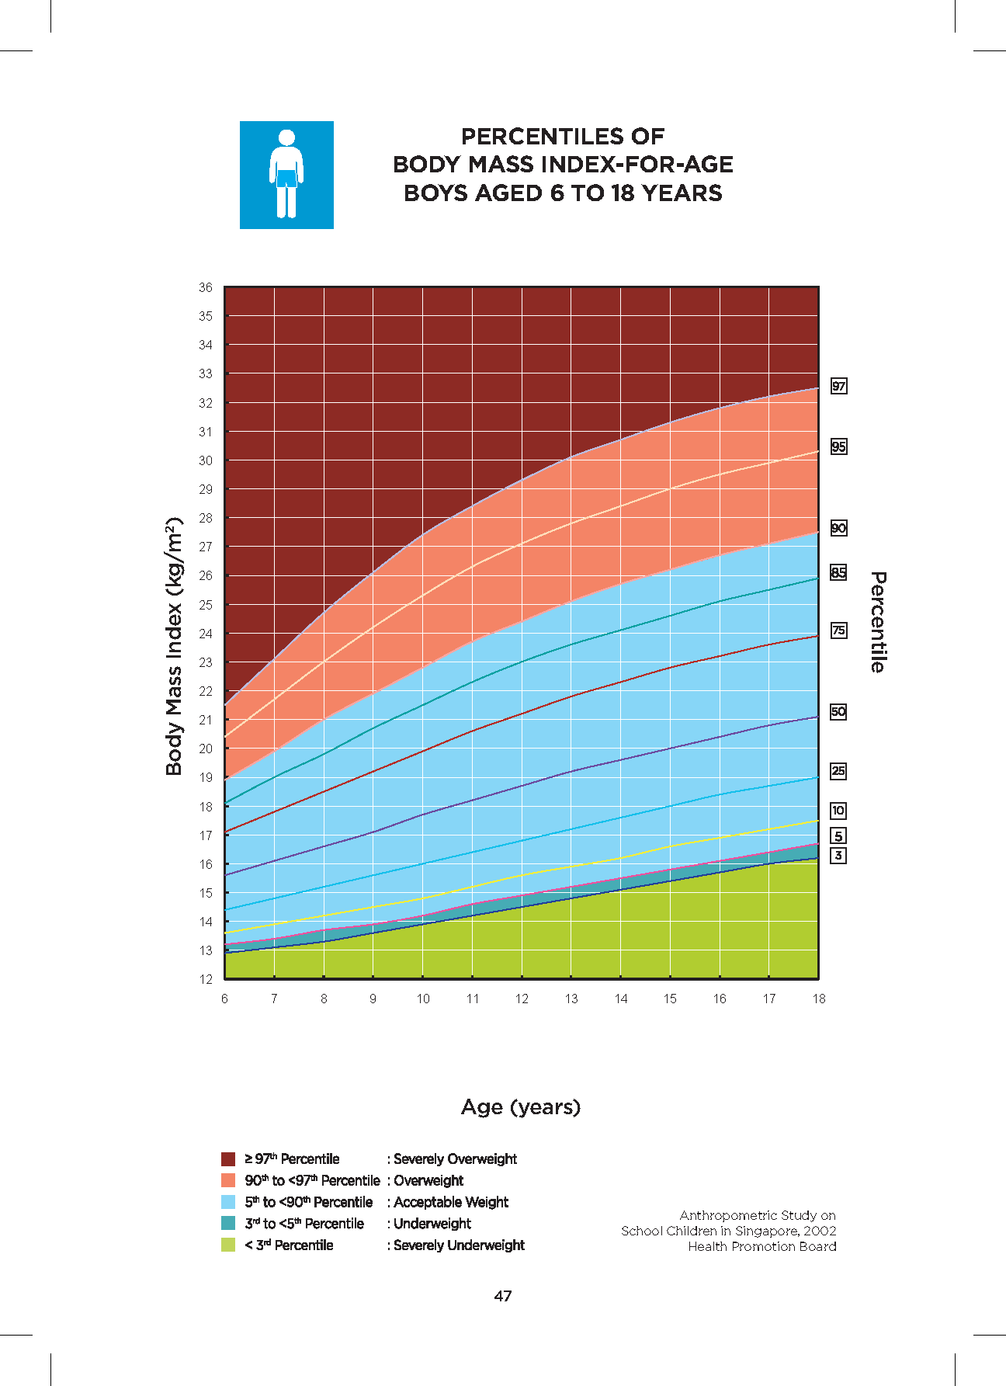

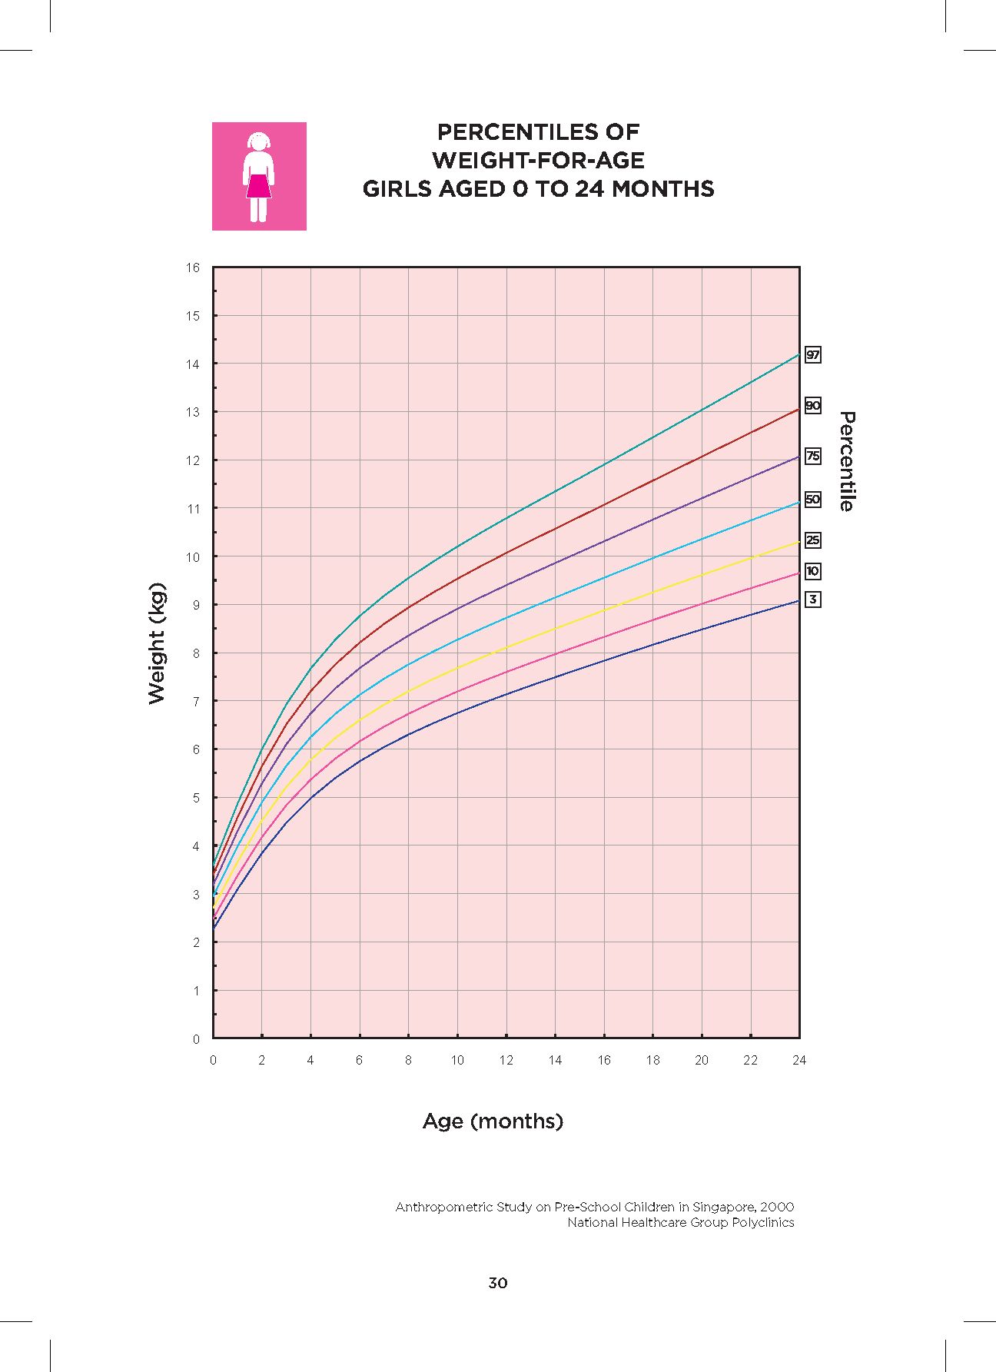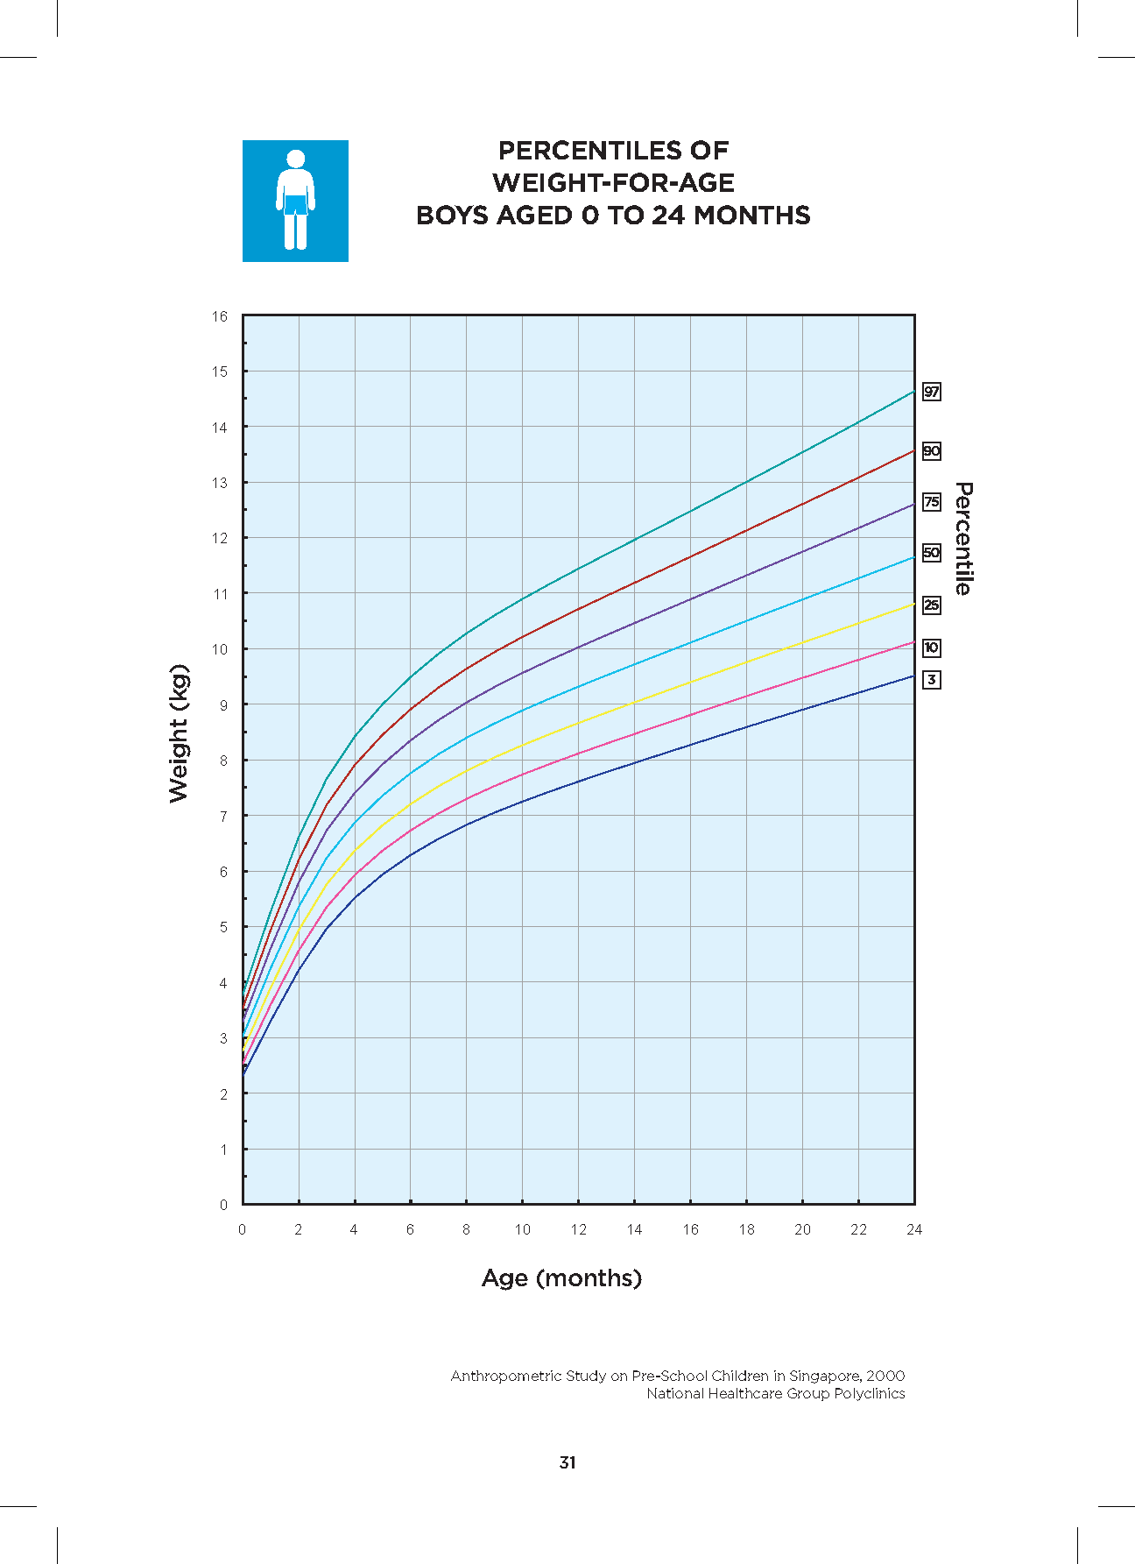

c) Laboratory Investigations

Routine investigations are unnecessary for normal children undergoing minor surgery, and are not ordered unless the history/ physical examination suggests otherwise.

For major operations, the following investigations may be required:

* FBC including platelets.
* Urea, electrolytes and glucose
* PT/PTT
* GXM or Type and screen.
* ECG / CXR
* LFT or any other relevant investigations like 2D echocardiograms

*References:*

1. *Black AE. Medical assessment of the paediatric patient. British Journal of Anaesthesia 1999; 83(1):3-15.*
2. *Cook-Sather SD, Harris KA, Chiavacci R et al. A liberalised fasting guideline for formula-fed infants does not increase average gastric fluid volume before elective surgery. Anesthesia and Analgesia 2003; 96: 965-969*
3. *McCann ME, Kain ZN. The Management of Preoperative Anxiety in Children: An Update. Anesth Analg 2001; 93: 98-105.*
4. *Practice Guidelines for Preoperative Fasting and the Use of Pharmacologic Agents to Reduce the Risk of Pulmonary Aspiration: Application to Healthy Patients Undergoing Elective Procedures. A Report by the American Society of Anesthesiologists Task Force on Preoperative Fasting. Anesthesiology 1999; 90: 896 – 905*
5. *Thomas M, Morrison C, Newton R, et al. Consensus statement on clear fluids fasting for elective pediatric general anesthesia. Paediatr Anaesth. 2018; 28:411–4*